- Visual Studio
  - Create a stored procedure that drives the report
    - Parameters
The parameters for the query should be the same as the ones you're going to prompt the user for. Here's what my usprptcompliancehistory looks like:
ALTER PROCEDURE [dbo].[uspRptComplianceHistory]
@Lot varchar(100) = null,
@Lane varchar(100) = null
AS
BEGIN
SET NOCOUNT ON;
if @Lot is null begin -- null values for Crystal Reports so that it sets
the lengths correctly
SELECT
cast(0 as int) as crReviewId,
cast (getdate() as DateTime) as crDate,
cast ('' as varchar(100)) as crLot,
cast ('' as varchar(100)) as crLane,
cast (0 as int) as crSubmittalID,
cast ('' as varchar(max)) as crComments,
cast ('' as varchar(max)) as crCorrection,
cast ('' as varchar(max)) as crRule,
cast ('' as varchar(max)) as crFollowUp,
cast (getdate() as DateTime) as crCloseDate,
cast ('' as varchar(6)) as crOpenClosed
end else begin
SELECT
cr.crReviewID, cr.crDate, cr.crLOT, cr.crLANE, cr.crSubmittalID,
cr.crComments, cr.crCorrection, cr.crRule, cr.crFollowUp, cr.crCloseDate,
CASE WHEN crCloseDate is null then 'OPEN' ELSE 'CLOSED' END as
crOpenClosed
FROM tblComplianceReview cr
WHERE (((cr.crLOT)=@Lot) AND ((cr.crLANE)=@Lane))
ORDER BY cr.crReviewID;
END
END
    - Create two SELECTS
      - One for when non-null params are supplied
      - One for when null params are supplied where each field is returned with data types defined explicitly. The reason for this latter is that in the course of designing a report, Crystal Reports will frequently ask you to supply params. Aside from when you're running a preview (Main Report Preview tab), the only reason Crystal Reports is doing this is to establish its own internal datatype settings for each field in the report. So … not only is it faster to not have to supply values for these parameters repeatedly; but more importantly, if you don't explicitly defined datatypes/lengths, Crystal Reports will make some internal assumptions about the field types and lengths which are sometimes incorrect. It will take, for example, as a varchar length for a given varchar field the length of longest one returned in the query that executes based on the parameters you've supplied. So, if the longest Address1 field returned is 16 characters long, then Crystal Reports establishes for its own internal purposes this length; and if, at some other time, an Address1 comes back longer than that, Crystal Reports simply truncates it! (This “gotcha” takes quite awhile to debug.)
  - Create Report
    - Right click folder where you want to place the report.
    - Add, New Item, Reports, CrystalReport
  - Report Wizard
(Note: all of the things that you indicate in the Report Wizard are modifiable during the report design. The Report Wizard simply gives you a good jump-start.)
    - Select Using the Report Wizard
    - 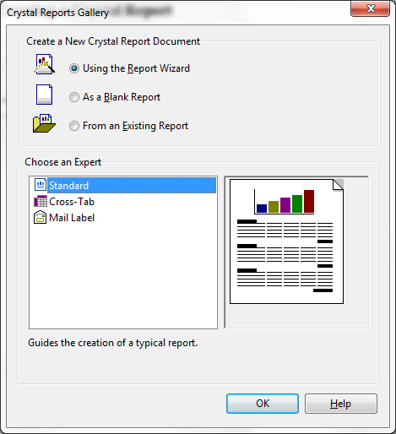Data Connection and data source
If you're creating a new Data connection, click Create New Connection, and select OLE DB (ADO); and then choose SQL Server Native Client 11.0. (SQL Native Client, and Microsoft OLE DB Provider for SQL Server will work, too)
Crystal Reports asks you to supply parameter values (that is, if there are parameters involved in the Stored Procedure). Leave “Set to Null” as checked for all values, and click Okay
    - Fields – select them all
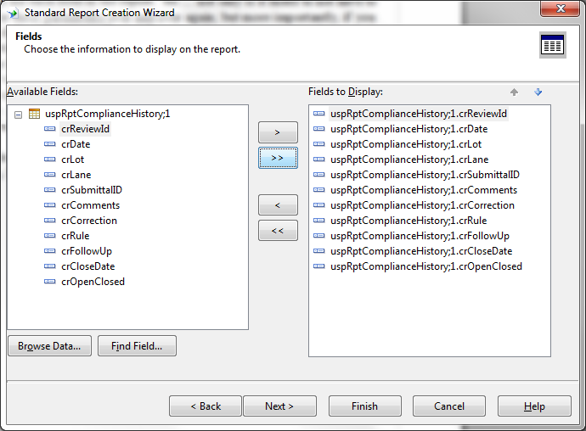
    - Grouping – If your report is going to have levels of reporting that has subtotals, here's a place you can designate the grouping field(s)
    - Record Selection
Just hit Next. (I believe that this part of the Report Wizard gives you the ability to filter data; but our techique is to ask the user for report parameters in our App, and then to pass these values to our stored procedure.)
    - Report Style - Standard
- Crystal Reports design view
  - Results of the Report Wizard - go ahead and click the Main Report Preview tab to see what you've got so far.
  - Fill in Report Header
Use Right-click, Insert to insert a text object, a line, or an image.
Expand the Report Header section by positioning your cursor at the top the the Page Header section and dragging it down.
  - Fill in the Report Footer
Quick trick: to align several fields at once, select multiple fields (holding down the Ctrl key), selecting the field you wish to align to last. Right-click, Align, Bottoms (for example).
  - Fill in the Page Header
Note: for the Compliance History report, I've deleted the headings that the Report Wizard gave me. Note how I dragged the fields that I wanted from the Field Exlorer over to the report. (I could have just as well used the crLot and crLane fields from the Database Fields section.)
Notes:
  - Hit Alt-F-Save often
  - Any time you want, click on Main Report Preview to see how you're doing. If you want to refresh the parameters, right-click on the report, and click Refresh
  - Another selection trick: you can click, holddown, and draw a rectangle around a bunch of fields, and all of those fields will be selected for you.
  - Format Detail page
    - Drag and drop fields from the Field Explorer – Database Fields.
    - Insert headings by right-clicking anywhere on the report, Insert Text Object
    - Indicate special data formatting for a specific field by right-clicking the field, Format Object. In this case, I'm formatting the Inspection Date field (crDate) so that it appears as Month day, year
- Other Crystal Report issues
  - If you change your query, you need to communicate this to Crystal Reports by right-clicking Database Fields in the Field Explorer, and clicking Verify Database.
  - Important point: when you create a report, it asks you to indicate the database connection and the data source. It needs this information because it needs to know all about the fields, field lengths, and so forth. I've, of course, been using my local development database for this. Crystal Reports in Visual Studio supports dynamic database connections – in other words, the ability to choose the database connection programmatically. And I've incorporated this functionality in our app … basing it on what is the web.config connection settings. But, what if you want to view the the report in the Main Report Preview, using a different connection? To do this, right-click Database Fields in the Field Explorer, and click Set Datasource Location. The top part shows the current connection and data source. In the bottom part, find the same stored procedure name.
Then (and this part is not user intuitive):
    - Click the top name to select it. (this will light up the “Update” button.
    - Then click the same name in the below section.
    - Then click Update

  - Gotcha
Crystal Reports has lots of “gotchas”. For instance, when I first was creating the Compliance History report, I put all of the detail fields into Section 3 Details. But I found that the data fields that are multiple lines were bleeding into the next field. Also – and this is really wild – the borders that I defined for each field decided to encompass both the one field, as well as the next field.
To get around this, I divided the Detail Section into separate sub-sections (Details a, Details b, and so forth). You do this by right-clicking the Detail section, and taking the Insert Section Below option. I then placed any lines that can grow into their own sub-section.

- Hooking the report into our Visual Studio application
Reports are part of a framework that I created, making it so you only have to supply the things that make this report distinct.
  - Step 1 – Create Web Form Using Master Page, indicating that its Master Page is ~/Reports/Reports.Master
  - Step 1a – Go to the code view for this page, and inherit it from AbstractReport
    - Replace
protected void Page_Load(object sender, EventArgs e) {
with
protected override void child_Page_Load(object sender, EventArgs args) {
  - Step 2 – Define user input fields
Define the input controls in the ContentPlaceHolderReportParms section of the .aspx file.
  - Step 3 – Create the overrided methods
    - getReportDocument – returns an instance of the Crystal Report that you just created.
    - GetIgnoreSubreportsWhenBuildingParameters – return true (some day, if we get into Crystal Reports' sub-report capability, then this parameter may be false. (Further explanation: Subreports often have parameters There are two ways to hook your parameters in a sub-report.
      - One is where you define links from the main report into the sub-report. If you go this route, or if there aren't any sub-reports in the first place, then return true.
      - The other is where we supply the sub-reports parameters from the visual studio program, programmatically; in which case you would return false.
    - getReportParams
Return a Hashtable whose key is the parameter name in the stored procedure (including the “@”), and whose value is the value of the item the the user has indicated.
  - Step 4 – Add a link to either ComplianceReviewReportsMain, BperminReportsMain, or SubmittalReportsMain for the report. OnClick, do a Reponse.Redirect to the aspx file created in Step 1.

